Teraterm Console Installation and Use
Jody Lewis

Teraterm Console Installation and Use 1
Overview 2
Installation 2
Usage 3
Telnet Connection 3
Serial Connection 3
Logging 4
Scripts 5
Cut and Paste 5

Overview
Teraterm is a free terminal emulation program that can be used as a serial console or telnet console.

Installation
If you haven’t unzipped the files from TTERM.zip please do so. This creates a folder called “TTERM” Inside the folder you should see three files:

Readme - Teraterm Console.doc | this file
TERATERM.INI | a custom Teraterm initialization file
teraterm_utf8-4.55.exe | the Teraterm installer

Run the teraterm_utf8-4.55.exe program. Take all the default selections till you come to the “Select Component” screen.

Here select “Compact Installation”:
This installs only the terminal program (TTSSH). The other programs are of dubious value for our needs.

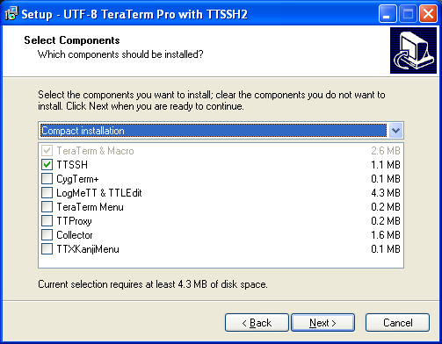

Take the remaining defaults.

Once the program is installed please copy the “TERATERM.INI” file to the installation directory (C:\Program Files\teraterm). This gives us a friendlier setup (colors, titles, options).

Usage

Telnet Connection
When you start Teraterm you will get the “New connection” box. Click on the TCP/IP button and enter the IP address of the device you want to connect to. Click OK and you should be good to go:

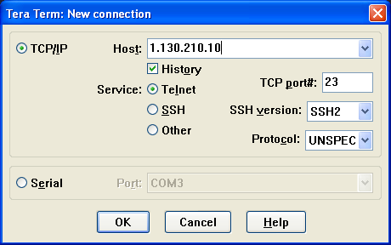

The most recent connections are remembered and can be selected from the list subsequently.

Serial Connection
When you start Teraterm you will get the New connection box. Click on the Serial button and select the communications port (typically COM1 or COM2). Click OK and you should be good to go:

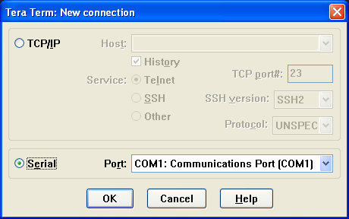

If you need to change the serial port setup select Setup/Serial Port… from the menu. The default parameters are 9600 Baud, 8-bit data, no parity, 1 stop bit, and no flow control:

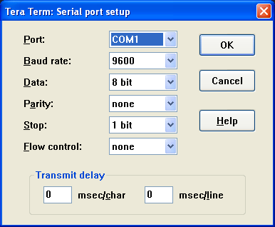

Logging
To log the output of the console select File/Log… from the menu. Enter a file if desired and select options as desired (Typically Plain text and then Append or not as desired). Press the Save button to start logging:

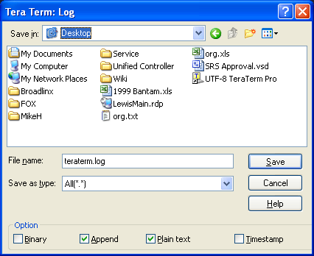

Once logging is started you will get a log control window (it will be minimized). From here you can pause or close the log file:

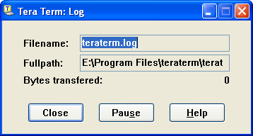

Scripts
Any text file can be used as a script file (e.g., using Notepad create a text file with command in it. Make sure it ends with an empty line).

Cut and Paste
Control characters have special meaning to embedded systems so Control C and Control V are not used to cut and paste.

To copy text from the console simply left click and drag. The highlighted text is automatically copied and can be pasted in another (or the same) window.

To paste text into the console window simply right click. Be careful as it will happily paste whatever is in the copy buffer without warning.

